PUBLIC NOTICE
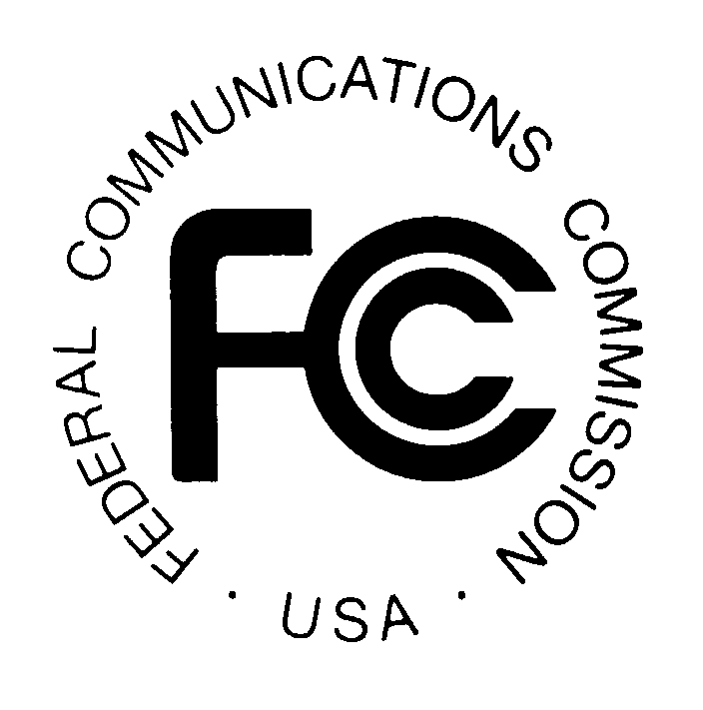

News media information 202 / 418-0500
Fax-On-Demand 202 / 418-2830
TTY 202 / 418-2555
Internet: http://www.fcc.gov
ftp.fcc.gov

Federal Communications Commission
445 12th St., S.W.
Washington, D.C. 20554

DA 00-2566
November 2, 2001

WIRELESS TELECOM ACTION

NEW ENGLAND (REGION 19) 700 MHz PUBLIC SAFETY
PLANNING COMMITTEE ANNOUNCES PLANNING MEETING

The New England (Region19) 700 MHz Public Safety Planning Committee announces that its next meeting will be held on Tuesday, December 11, 2001 at 10:00 a.m., at the Emergency Operations Center, Office of Emergency Management, 645 New London Avenue, Cranston, Rhode Island. The purpose of the meeting is to:

- Approve Minutes of the September 26, 2001 Meeting,
- Initiate the State License Application Process,
- Discuss the 700 MHz FCC Planning Process, and
- Formulate Committee and Review Plan Development.

The Region 19 700 MHz Public Safety Planning Committee meeting is open to the public. All eligible public safety providers whose sole purpose or principal purpose is to protect the safety of life, health, or property in the States of Massachusetts, Rhode Island, Maine, Vermont, New Hampshire, and the Counties of New London, Windham, Tolland and Hartford within the state of Connecticut would utilize these frequencies. It is essential that participants be representatives of all eligible public safety providers in order to ensure that each agency’s future spectrum needs are considered in the allocation process. Administrators who are not oriented in the communications field should delegate someone with this knowledge to attend, participate and represent their agency’s needs.

All interested parties wishing to participate in the planning for the use of new public safety spectrum in the 700 MHz band should plan to attend. For further information, please contact:

George J. Pohorilak, Chairman
Region 19, 700 MHz Public Safety Planning committee
Office of Statewide Emergency Telecommunications
1111 Country Club Road
Middletown, CT 06457-9294
(860) 685-8108 (voice)
(860) 685-8363 (fax)
Email: george.pohorilak@po.state.ct.us

-FCC-

